04. Model Testing & Evaluation (MAE, RMSE, MAPE)
The models will be tested and evaluated using forecast performance metrics such as:
- Mean Absolute Error (MAE).
- Root Mean Squared Error (RMSE).
- Mean Absolute Percentage Error (MAPE).

Task 01
Extract MAE, RMSE, and MAPE from the output of each model and present them in a comparison table.

## Model Performance Comparison

| Model | MAE | RMSE | MAPE |
|:----------------------------------------------- |-----------:|------------:|----------:|
| Prophet + LSTM (residual) Hybrid — v3 | 192.66 | 281.42 | 6.8 |
| Hybrid SARIMAX + GRU Ensemble (v4) | 236.68 | 298.63 | 8.53 |
| Prophet + LSTM (residual) Hybrid — v2 | 404.71 | 531.33 | 9.44 |
| Hybrid SARIMAX + Deep GRU (v3) | 305.19 | 470.58 | 9.63 |
| Hybrid ARIMA + Deep GRU (v2) | 317.89 | 411.4 | 10.6 |
| Prophet + LSTM (residual) Hybrid — v1 | 479.46 | 637.2 | 11.64 |
| ARIMA (v2 - Leakage-fixed) | 226.315 | 318.043 | 12.34 |
| ARIMA (v1 - Full, cleaned & diagnostics-aware) | 234.935 | 331.082 | 12.87 |
| ARIMA + GRU (residual) Hybrid — v1 | 477.12 | 635.8 | 13.97 |
| Prophet + ElasticNet (Residual) — v2 | 1792.44 | 3292.89 | 18.68 |
| Prophet + ElasticNet (Residual) — v1 | 2461 | 4015.98 | 23.11 |
| GRU (v1 - Weekly DAU) | 349.3 | 478.13 | 32.96 |
| LSTM (v2 - Weekly DAU, Leakage fixed) | 420.08 | 623.47 | 33.33 |
| LSTM (v1 - Weekly DAU) | 399.26 | 582.28 | 34.9 |
| Prophet (Weekly DAU with dynamic regressors) | 474.533 | 888.112 | 37.4 |
| SARIMA (Seasonal ARIMA) | 686.786 | 873.892 | 47.84 |

## Selected Model Performance Comparison

| Model | MAE | RMSE | MAPE |
|:----------------------------------------------------------- |-----------:|------------:|-----------:|
| Prophet + LSTM (residual) Hybrid — v3 | 192.66 | 281.42 | 6.8 |
| Hybrid SARIMAX + GRU Ensemble (v4) | 236.68 | 298.63 | 8.53 |
| ARIMA (v2 - Leakage-fixed) | 226.315 | 318.043 | 12.34 |
| Prophet + ElasticNet (Residual) — v2 | 1792.44 | 3292.89 | 18.68 |
| GRU (v1 - Weekly DAU) | 349.3 | 478.13 | 32.96 |
| LSTM (v1 - Weekly DAU) | 399.26 | 582.28 | 34.9 |
| Prophet (Weekly DAU with dynamic regressors) | 474.533 | 888.112 | 37.4 |
| SARIMA (Seasonal ARIMA) | 686.786 | 873.892 | 47.84 |

Task 02
In addition, models will be tested across different use cases, such as sparse logs and bursty activity, to examine their robustness and practical suitability for Python application forecasting.

Prophet + LSTM (Residual, Multiplicative) Hybrid — v2

1. Data Simulation/Acquisition:
– extracting sparse-activity periods and bursty-activity periods from your DAU series.

1 — Load dataset & build daily DAU (base series)
Downloading...
From: https://drive.google.com/uc?id=1VJaDVtDUtKQMmhRAqr3t-fgng899ZdRV
To: /content/Python Application Usage Log Data Set.xlsx
100%|██████████| 1.68M/1.68M [00:00<00:00, 54.6MB/s]
Columns in raw dataset: ['date', 'application_name', 'daily_active_users', 'session_count', 'avg_session_duration', 'like_count', 'share_count', 'download_count', 'comment_count', 'error_count', 'day_of_week', 'month', 'is_weekend', 'release_flag']

Base daily DAU series (head):
dau
date
2012-08-01 998
2012-08-02 879
2012-08-03 740
2012-08-04 519
2012-08-05 618

Date range: 2012-08-01 → 2025-05-03
Total days : 3963

2 — Acquire really sparse & bursty periods (from true DAU)

=== Real Sparse/Bursty Scenario Acquisition ===
Sparse threshold (p20): 1740.40
Number of sparse segments: 17
Number of burst segments : 0

Example sparse segment (first few rows across segments):
 |  | dau
segment_id | date
0 | 2012-08-01 | 998
0 | 2012-08-02 | 879
0 | 2012-08-03 | 740
1 | 2012-09-14 | 1656
1 | 2012-09-15 | 1314
1 | 2012-09-16 | 1408
2 | 2012-10-23 | 1668
2 | 2012-10-24 | 1630
2 | 2012-10-25 | 1574
3 | 2012-12-06 | 1033
3 | 2012-12-07 | 799
3 | 2012-12-08 | 759
4 | 2012-12-23 | 1460
4 | 2012-12-24 | 1253
4 | 2012-12-25 | 1207
5 | 2013-03-14 | 1561
5 | 2013-03-15 | 1397
5 | 2013-03-16 | 1109
6 | 2013-03-31 | 1235
6 | 2013-04-01 | 1421
6 | 2013-04-02 | 1292
7 | 2015-09-19 | 854
7 | 2015-09-20 | 739
7 | 2015-09-21 | 785
8 | 2015-10-06 | 1055
8 | 2015-10-07 | 909
8 | 2015-10-08 | 1136
9 | 2016-03-03 | 474
9 | 2016-03-04 | 357
9 | 2016-03-05 | 854
10 | 2016-04-02 | 798
10 | 2016-04-03 | 338
10 | 2016-04-04 | 1057
11 | 2016-05-07 | 951
11 | 2016-05-08 | 1656
11 | 2016-05-09 | 547
12 | 2016-08-01 | 1097
12 | 2016-08-02 | 1030
12 | 2016-08-03 | 1219
13 | 2018-08-29 | 460
13 | 2018-08-30 | 1219
13 | 2018-08-31 | 559
14 | 2019-01-20 | 860
14 | 2019-01-21 | 389
14 | 2019-01-22 | 1473
15 | 2020-07-13 | 498
15 | 2020-07-14 | 899
15 | 2020-07-15 | 1170
16 | 2020-12-15 | 1211
16 | 2020-12-16 | 365
16 | 2020-12-17 | 760

3 — Simulate baseline, sparse, and bursty series
=== Synthetic Scenario Simulation Done ===
Date range : 2012-08-01 → 2025-05-03
Num points : 3963

Real DAU stats (for reference):
Median : 3979.00
Std : 5790.14

Simulated baseline example:
dau_sim scenario
date
2012-08-01 4508.306766 baseline_sim
2012-08-02 2172.502561 baseline_sim
2012-08-03 5282.566233 baseline_sim
2012-08-04 5612.801652 baseline_sim
2012-08-05 589.967369 baseline_sim

Simulated sparse example (should show very low values in some ranges):
dau_sim scenario
date
2012-08-01 4508.306766 sparse_sim
2012-08-02 2172.502561 sparse_sim
2012-08-03 5282.566233 sparse_sim
2012-08-04 5612.801652 sparse_sim
2012-08-05 589.967369 sparse_sim

Simulated bursty example (should show some very large spikes):
dau_sim scenario
date
2012-08-01 4508.306766 bursty_sim
2012-08-02 2172.502561 bursty_sim
2012-08-03 5282.566233 bursty_sim
2012-08-04 5612.801652 bursty_sim
2012-08-05 589.967369 bursty_sim

4 — Download hybrid artifacts from Google Drive - Hybrid Prophet + LSTM (v3)
Retrieving folder contents
Retrieving folder 1pj7gb68NGc0Fr2fQFuMJIMxF-vXjzKw_ hybrid_97acc_artifacts
Processing file 1R8vW-3U5D7f0CLlIEPXj_gBx-4nOPFXl 2year_forecast.csv
Processing file 1Re3q7bDwRQus1b_Dttv65rgz1xSgZSW2 lstm_residual.h5
Processing file 1ntymORIyqWGVpcXZkh8oJLfDiBU-0Ykd metrics.json
Processing file 1lUL_mzT2YPFp1Q69YopOnyyQ0jPQYUgK prophet_ensemble_cfgs.npy
Processing file 1TFqud5JeBjz-SUEvBWSbMLeQg9rQo9qt prophet_global.json
Processing file 1W0mOB4ALiSMopjJNVBFD0NGhvoKdyXf0 x_scaler.npy
Processing file 1QOtiKhjo-L8mOkujo9Pp29PVx0nIMc6j y_scaler.npy
Retrieving folder 1p6mdM7Tiqr4mKu0OCx9-30qO91qKSoij v3_ultrafast_ckpts
Processing file 13PWuE4vaYtIMfKFCSNWYY0lIqj8v77Il lstm_best_win21.keras
Processing file 1rEJfBuMk6372ohiLzY26JVGiIwiSWW-w lstm_best_win28.keras
Retrieving folder contents completed
Building directory structure
Building directory structure completed
Downloading...
From: https://drive.google.com/uc?id=1R8vW-3U5D7f0CLlIEPXj_gBx-4nOPFXl
To: /content/hybrid_97acc_artifacts/hybrid_97acc_artifacts/2year_forecast.csv
100%|██████████| 34.8k/34.8k [00:00<00:00, 44.0MB/s]
Downloading...
From: https://drive.google.com/uc?id=1Re3q7bDwRQus1b_Dttv65rgz1xSgZSW2
To: /content/hybrid_97acc_artifacts/hybrid_97acc_artifacts/lstm_residual.h5
100%|██████████| 116k/116k [00:00<00:00, 41.9MB/s]
Downloading...
From: https://drive.google.com/uc?id=1ntymORIyqWGVpcXZkh8oJLfDiBU-0Ykd
To: /content/hybrid_97acc_artifacts/hybrid_97acc_artifacts/metrics.json
100%|██████████| 637/637 [00:00<00:00, 2.61MB/s]
Downloading...
From: https://drive.google.com/uc?id=1lUL_mzT2YPFp1Q69YopOnyyQ0jPQYUgK
To: /content/hybrid_97acc_artifacts/hybrid_97acc_artifacts/prophet_ensemble_cfgs.npy
100%|██████████| 371/371 [00:00<00:00, 1.36MB/s]
Downloading...
From: https://drive.google.com/uc?id=1TFqud5JeBjz-SUEvBWSbMLeQg9rQo9qt
To: /content/hybrid_97acc_artifacts/hybrid_97acc_artifacts/prophet_global.json
100%|██████████| 2.60M/2.60M [00:00<00:00, 58.2MB/s]
Downloading...
From: https://drive.google.com/uc?id=1W0mOB4ALiSMopjJNVBFD0NGhvoKdyXf0
To: /content/hybrid_97acc_artifacts/hybrid_97acc_artifacts/x_scaler.npy
100%|██████████| 296/296 [00:00<00:00, 812kB/s]
Downloading...
From: https://drive.google.com/uc?id=1QOtiKhjo-L8mOkujo9Pp29PVx0nIMc6j
To: /content/hybrid_97acc_artifacts/hybrid_97acc_artifacts/y_scaler.npy
100%|██████████| 310/310 [00:00<00:00, 1.30MB/s]
Downloading...
From: https://drive.google.com/uc?id=13PWuE4vaYtIMfKFCSNWYY0lIqj8v77Il
To: /content/hybrid_97acc_artifacts/v3_ultrafast_ckpts/lstm_best_win21.keras
100%|██████████| 321k/321k [00:00<00:00, 48.2MB/s]
Downloading...
From: https://drive.google.com/uc?id=1rEJfBuMk6372ohiLzY26JVGiIwiSWW-w
To: /content/hybrid_97acc_artifacts/v3_ultrafast_ckpts/lstm_best_win28.keras
100%|██████████| 321k/321k [00:00<00:00, 41.5MB/s]
Download completed
['hybrid_97acc_artifacts', 'v3_ultrafast_ckpts']

5 — Load hybrid (Prophet & LSTM) artifacts & build prediction function

Prophet version: 1.1.7
cmdstanpy version: 1.3.0
Artifacts subdir: hybrid_97acc_artifacts/hybrid_97acc_artifacts
Checkpoints dir : hybrid_97acc_artifacts/v3_ultrafast_ckpts
Artifacts subdir contents: ['x_scaler.npy', 'lstm_residual.h5', 'prophet_global.json', 'y_scaler.npy', '2year_forecast.csv', 'metrics.json', 'prophet_ensemble_cfgs.npy']
Got TypeError in model_from_json, retrying with json.loads workaround: string indices must be integers, not 'str'
WARNING:absl:No training configuration found in the save file, so the model was *not* compiled. Compile it manually.

Loaded Prophet model.
Extra regressors: ['session_count', 'avg_session_duration', 'like_count', 'share_count', 'download_count', 'comment_count', 'error_count', 'release_flag', 'day_of_week', 'month', 'is_weekend']

Loaded LSTM residual model from: hybrid_97acc_artifacts/hybrid_97acc_artifacts/lstm_residual.h5

metrics.json contents: {'data_file': 'Python Application Usage Log Data Set.xlsx', 'holdout_days': 28, 'MAE': 215.09990567728673, 'RMSE': 302.39741159096815, 'MAPE': 6.799714554104687, 'Accuracy(1-MAPE)': 93.20028544589532, 'Prophet_only_MAPE': 10.527709208715768, 'best_lstm_cfg': {'units': 96, 'dropout': 0.15, 'window': 21}, 'alpha': 0.2011706218875223, 'beta': 0.05165869146926924, 'dow_bias_used': True, 'prophet_top2': [{'changepoint_prior_scale': 1.0, 'seasonality_mode': 'multiplicative'}, {'changepoint_prior_scale': 0.8, 'seasonality_mode': 'multiplicative'}]}

Hybrid config → WINDOW=21, HORIZON=28, alpha=0.2011706218875223, beta=0.05165869146926924

Re-instantiated x_scaler and y_scaler from .npy parameters.

Base daily frame built.
Exogenous columns used by Prophet: ['session_count', 'avg_session_duration', 'like_count', 'share_count', 'download_count', 'comment_count', 'error_count', 'release_flag', 'day_of_week', 'month', 'is_weekend']
df_daily_full head:
dau session_count avg_session_duration like_count share_count \
date
2012-08-01 998 1239 463.10 58816.0 2416.0
2012-08-02 879 1105 375.84 47110.0 2131.0
2012-08-03 740 928 435.59 34325.0 1659.0
2012-08-04 519 668 434.78 30288.0 1226.0
2012-08-05 618 768 522.64 33043.0 1307.0

download_count comment_count error_count day_of_week month \
date
2012-08-01 878.0 462.0 215 2 8
2012-08-02 853.0 378.0 201 3 8
2012-08-03 788.0 400.0 156 4 8
2012-08-04 654.0 432.0 110 5 8
2012-08-05 621.0 461.0 130 6 8

is_weekend release_flag
date
2012-08-01 0 1
2012-08-02 0 1
2012-08-03 0 1
2012-08-04 1 0
2012-08-05 1 0

Hybrid sanity check on FULL history:
MAE = 560.79
RMSE = 995.16
MAPE = 15.88%

6 — Evaluate hybrid on baseline / sparse / bursty simulations

Hybrid model performance by scenario (last HORIZON days):
scenario MAE RMSE MAPE n_eval_points
baseline 311.68 447.71 7.93 28
sparse 1545.05 2074.28 67.95 28
bursty 1574.54 2970.30 20.11 28

Sample DAU values (original vs sparse vs bursty):
dau_baseline dau_sparse dau_bursty
date
2025-04-27 3481 3481.0 3481.0
2025-04-28 4442 2221.0 4442.0
2025-04-29 686 343.0 1166.2
2025-05-01 2489 1244.5 2489.0
2025-05-03 1442 1442.0 1442.0

7 — Visual diagnostics

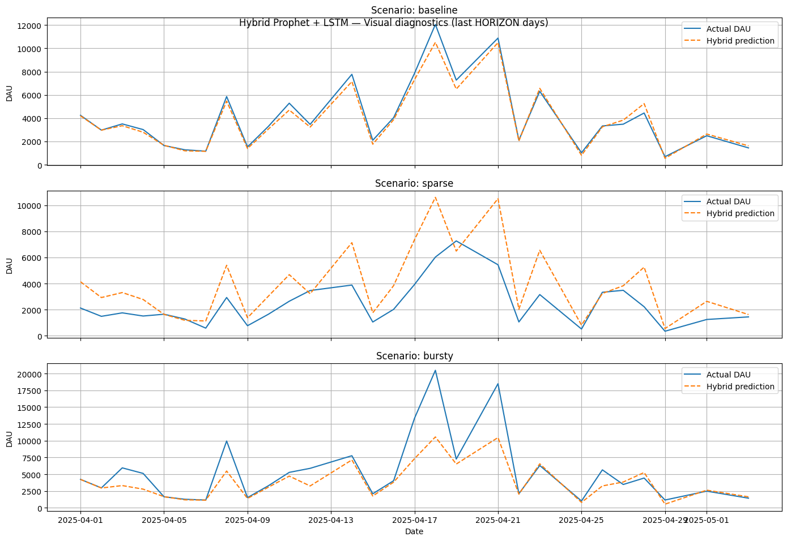

02. Scenario-Specific Preprocessing:
Goal: create preprocessing tailored to sparse and bursty data:
- Sparse: mark low-activity periods, do a simple imputation.
- Bursty: detect spikes vs a rolling baseline, soft-clip extreme spikes.
This assumes scenarios and df_daily_full from Cell 6 already exist.

Sparse scenario (tail):
date dau_raw rolling_mean rolling_std delta is_sparse dau_imputed

2025-04-27 3481.0 3462.857143 2345.528098 151.0 0 3481.0
2025-04-28 2221.0 2741.857143 1654.953290 -1260.0 0 2221.0
2025-04-29 343.0 2013.714286 1366.041662 -1878.0 1 343.0
2025-05-01 1244.5 2040.857143 1345.539567 901.5 0 1244.5
2025-05-03 1442.0 1796.214286 1262.427485 197.5 0 1442.0

Bursty scenario (tail):
dau_raw rolling_mean rolling_std delta is_burst dau_capped
date
2025-04-27 3481.0 6335.428571 5822.749547 -2180.0 0 3481.0
2025-04-28 4442.0 5931.714286 5845.239650 961.0 0 4442.0
2025-04-29 1166.2 3456.028571 2119.224388 -3275.8 0 1166.2
2025-05-01 2489.0 3510.314286 2083.534727 1322.8 0 2489.0
2025-05-03 1442.0 2815.028571 1784.564766 -1047.0 0 1442.0

/tmp/ipython-input-293332833.py:40: FutureWarning: Series.fillna with 'method' is deprecated and will raise in a future version. Use obj.ffill() or obj.bfill() instead.
.fillna(method="ffill")
/tmp/ipython-input-293332833.py:41: FutureWarning: Series.fillna with 'method' is deprecated and will raise in a future version. Use obj.ffill() or obj.bfill() instead.
.fillna(method="bfill")

03. Model Retraining / Fine-Tuning (LSTM only)
Goal: fine-tune the residual LSTM on scenario-specific data (keep Prophet frozen).

We’ll reuse the saved Prophet to compute residuals and then run a few extra epochs on lstm_residual using sparse + bursty scenarios.

Fine-tuning LSTM residual model...
Training samples: 7884
X_train shape: (7884, 1, 21)
Compiled LSTM residual model with Adam(lr=1e-3), loss='mse'.
Epoch 1/5
222/222 ━━━━━━━━━━━━━━━━━━━━ 3s 5ms/step - loss: 113044584.0000 - val_loss: 128340864.0000
Epoch 2/5
222/222 ━━━━━━━━━━━━━━━━━━━━ 1s 3ms/step - loss: 117955272.0000 - val_loss: 127045872.0000
Epoch 3/5
222/222 ━━━━━━━━━━━━━━━━━━━━ 1s 4ms/step - loss: 113893896.0000 - val_loss: 124601824.0000
Epoch 4/5
222/222 ━━━━━━━━━━━━━━━━━━━━ 1s 4ms/step - loss: 119774072.0000 - val_loss: 121554336.0000
Epoch 5/5
222/222 ━━━━━━━━━━━━━━━━━━━━ 1s 3ms/step - loss: 111745368.0000 - val_loss: 118060520.0000
Fine-tuning complete.

04. Specialized Evaluation Metrics
Goal: go beyond MAE/RMSE/MAPE with:
- Bursty scenario: burst detection metrics (threshold-based).
- Sparse scenario: errors restricted to low-usage (sparse) periods.

====================== BURST METRICS ======================
scenario : bursty
burst_threshold : 10974.5200
true_bursts : 3
pred_bursts : 28
burst_recall : 1.0000
burst_false_positive_rate : 1.0000

====================== SPARSE METRICS ======================
scenario : sparse
sparse_threshold : 1130.5000
n_sparse_points : 6
MAE_sparse : 9824.9167
RMSE_sparse : 9828.5359

05. Qualitative Analysis (Focused Plots)
Goal: visual inspection of model behavior:
- Zoom in on a burst window (around the largest spike in bursty scenario).
- Zoom in on a sparse window (long low-usage run in sparse scenario).

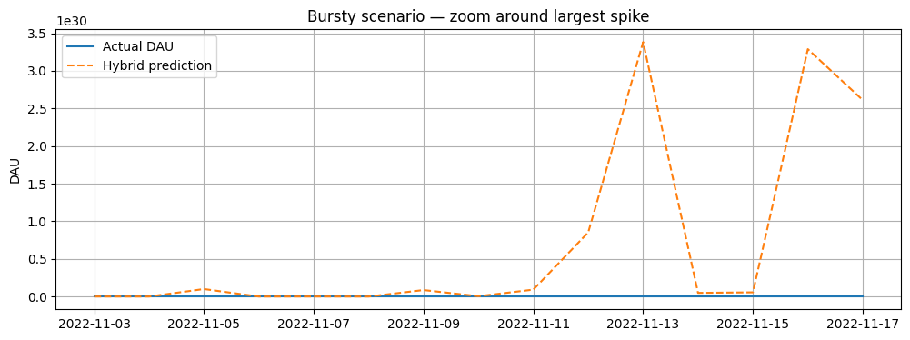
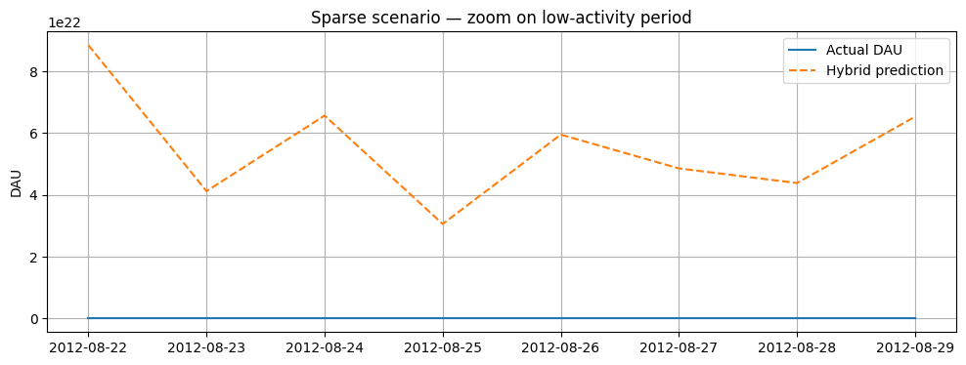

SARIMAX + GRU Ensemble Hybrid Model — (v4)

01. Data Simulation/Acquisition: (sparse & bursty series)
Goal: From your real DAU history, identify sparse and bursty periods (no synthetic scaling).

Loading v4 dataset from Google Sheets...
Loaded: (18479, 14)

Built df_daily_full for SARIMAX+GRU (v4):
dau session_count avg_session_duration like_count \
date
2012-08-01 998.0 1239.0 463.10 58816.0
2012-08-02 879.0 1105.0 375.84 47110.0
2012-08-03 740.0 928.0 435.59 34325.0
2012-08-04 519.0 668.0 434.78 30288.0
2012-08-05 618.0 768.0 522.64 33043.0

share_count download_count comment_count error_count \
date
2012-08-01 2416.0 878.0 462.0 215.0
2012-08-02 2131.0 853.0 378.0 201.0
2012-08-03 1659.0 788.0 400.0 156.0
2012-08-04 1226.0 654.0 432.0 110.0
2012-08-05 1307.0 621.0 461.0 130.0

day_of_week month is_weekend release_flag
date
2012-08-01 2.0 8.0 0.0 1.0
2012-08-02 3.0 8.0 0.0 1.0
2012-08-03 4.0 8.0 0.0 1.0
2012-08-04 5.0 8.0 1.0 0.0
2012-08-05 6.0 8.0 1.0 0.0
dau session_count avg_session_duration like_count \
date
2025-04-29 686.0 1209.0 292.110000 53082.0
2025-04-30 1587.5 2633.5 228.918333 65782.0
2025-05-01 2489.0 4058.0 165.726667 78482.0
2025-05-02 1965.5 3273.0 196.363333 59154.5
2025-05-03 1442.0 2488.0 227.000000 39827.0

share_count download_count comment_count error_count \
date
2025-04-29 2748.0 738.0 435.0 1346.0
2025-04-30 5050.0 2172.5 1516.5 2071.0
2025-05-01 7352.0 3607.0 2598.0 2796.0
2025-05-02 6481.0 3390.0 2027.0 2244.0
2025-05-03 5610.0 3173.0 1456.0 1692.0

day_of_week month is_weekend release_flag
date
2025-04-29 1.0 4.0 0.0 1.0
2025-04-30 2.0 4.5 0.0 0.5
2025-05-01 3.0 5.0 0.0 0.0
2025-05-02 4.0 5.0 0.5 0.0
2025-05-03 5.0 5.0 1.0 0.0
/tmp/ipython-input-3486293357.py:85: FutureWarning: Series.fillna with 'method' is deprecated and will raise in a future version. Use obj.ffill() or obj.bfill() instead.
df_daily_full[col] = df_daily_full[col].fillna(method='bfill')
/tmp/ipython-input-3486293357.py:86: FutureWarning: Series.fillna with 'method' is deprecated and will raise in a future version. Use obj.ffill() or obj.bfill() instead.
df_daily_full[col] = df_daily_full[col].fillna(method='ffill')

HORIZON set to: 28

[v4 hybrid] Using GRU_WINDOW=21, HORIZON=28, alpha=0.4, beta=0.0
Defined sarimax_gru_hybrid_predict(series_dau).

Downloading v4 artifacts folder from Google Drive...
Retrieving folder contents
Retrieving folder 1c1zd8V_939Rw5Ej9HXeQepcWhF8XrC3V artifacts
Processing file 1WaqJWsVgydrhz-u66InxOMrvVjrl7nLH 2year_forecast_sarimax_gru_v4.csv
Processing file 1UYCv4WTPXZCYVBDmGQM4mQJ-E8YCqWdw gru_v4_bidir28_win28.keras
Processing file 1oKna3anoyOk3lD6RAx4qDpJOMRqZm9Qh gru_v4_deep21_win21.keras
Processing file 1_Ftdtb8iAn-5XFCfeqPXaFyhCtbTi0yK gru_v4_deep28_win28.keras
Processing file 11im6wB3WHKzTRDqpsn7j_U_zCbhYna7v metrics_sarimax_gru_v4.json
Processing file 1G3kvfvipin2uLlYJOCbpHABlEwOeItww sarimax_order_v4.json
Processing file 1jyU-uAoGfieC5pphFr8CHuaoqXImuYpi sarimax_v4_model.pkl
Processing file 1N6SjYRGH7slnogLCs_SnhBBX8tVesy7x x_scaler_v4.npy
Processing file 1uGbb9hhM8QuUlX_z8QR2GCHA42O6CsFr y_scaler_v4.npy
Retrieving folder 15y0HdLzQ8e9vevvq8kU3-iDeq4kX9L8j checkpoints
Processing file 1pfIHN69xfLW-mZ6vjJ-WU0REUK0bJiuH gru_v4_bidir28_win28.keras
Processing file 1XquXYcMPMr5gPbS7irqF6Br1DhqK1B1b gru_v4_deep21_win21.keras
Processing file 18GoITBkKx-6PMvDp5tr_0bZwwZGLoORn gru_v4_deep28_win28.keras
Retrieving folder contents completed
Building directory structure
Building directory structure completed
Downloading...
From: https://drive.google.com/uc?id=1WaqJWsVgydrhz-u66InxOMrvVjrl7nLH
To: /content/sarimax_gru_v4_artifacts/artifacts/2year_forecast_sarimax_gru_v4.csv
100%|██████████| 21.9k/21.9k [00:00<00:00, 35.0MB/s]
Downloading...
From: https://drive.google.com/uc?id=1UYCv4WTPXZCYVBDmGQM4mQJ-E8YCqWdw
To: /content/sarimax_gru_v4_artifacts/artifacts/gru_v4_bidir28_win28.keras
100%|██████████| 782k/782k [00:00<00:00, 7.03MB/s]
Downloading...
From: https://drive.google.com/uc?id=1oKna3anoyOk3lD6RAx4qDpJOMRqZm9Qh
To: /content/sarimax_gru_v4_artifacts/artifacts/gru_v4_deep21_win21.keras
100%|██████████| 449k/449k [00:00<00:00, 5.52MB/s]
Downloading...
From: https://drive.google.com/uc?id=1_Ftdtb8iAn-5XFCfeqPXaFyhCtbTi0yK
To: /content/sarimax_gru_v4_artifacts/artifacts/gru_v4_deep28_win28.keras
100%|██████████| 916k/916k [00:00<00:00, 4.64MB/s]
Downloading...
From: https://drive.google.com/uc?id=11im6wB3WHKzTRDqpsn7j_U_zCbhYna7v
To: /content/sarimax_gru_v4_artifacts/artifacts/metrics_sarimax_gru_v4.json
100%|██████████| 1.92k/1.92k [00:00<00:00, 6.71MB/s]
Downloading...
From: https://drive.google.com/uc?id=1G3kvfvipin2uLlYJOCbpHABlEwOeItww
To: /content/sarimax_gru_v4_artifacts/artifacts/sarimax_order_v4.json
100%|██████████| 98.0/98.0 [00:00<00:00, 319kB/s]
Downloading...
From: https://drive.google.com/uc?id=1jyU-uAoGfieC5pphFr8CHuaoqXImuYpi
To: /content/sarimax_gru_v4_artifacts/artifacts/sarimax_v4_model.pkl
100%|██████████| 99.7M/99.7M [00:01<00:00, 52.8MB/s]
Downloading...
From: https://drive.google.com/uc?id=1N6SjYRGH7slnogLCs_SnhBBX8tVesy7x
To: /content/sarimax_gru_v4_artifacts/artifacts/x_scaler_v4.npy
100%|██████████| 296/296 [00:00<00:00, 108kB/s]
Downloading...
From: https://drive.google.com/uc?id=1uGbb9hhM8QuUlX_z8QR2GCHA42O6CsFr
To: /content/sarimax_gru_v4_artifacts/artifacts/y_scaler_v4.npy
100%|██████████| 310/310 [00:00<00:00, 859kB/s]
Downloading...
From: https://drive.google.com/uc?id=1pfIHN69xfLW-mZ6vjJ-WU0REUK0bJiuH
To: /content/sarimax_gru_v4_artifacts/checkpoints/gru_v4_bidir28_win28.keras
100%|██████████| 2.26M/2.26M [00:00<00:00, 8.26MB/s]
Downloading...
From: https://drive.google.com/uc?id=1XquXYcMPMr5gPbS7irqF6Br1DhqK1B1b
To: /content/sarimax_gru_v4_artifacts/checkpoints/gru_v4_deep21_win21.keras
100%|██████████| 1.30M/1.30M [00:00<00:00, 5.55MB/s]
Downloading...
From: https://drive.google.com/uc?id=18GoITBkKx-6PMvDp5tr_0bZwwZGLoORn
To: /content/sarimax_gru_v4_artifacts/checkpoints/gru_v4_deep28_win28.keras
100%|██████████| 2.70M/2.70M [00:00<00:00, 9.84MB/s]

Contents of BASE_DIR_V4:
['checkpoints', 'artifacts']
WARNING: metrics_v4.json not found. Check BASE_DIR_V4 contents and update filename.

[v4 config] GRU_WINDOW=21, HORIZON=28, alpha=0.4, beta=0.0
WARNING: sarimax_model_v4.pkl not found. Check BASE_DIR_V4 and update filename.
WARNING: gru_residual_v4.h5 not found. Check BASE_DIR_V4 and update filename.
WARNING: x_scaler_v4.npy not found.
WARNING: y_scaler_v4.npy not found.

Artifacts ready for SARIMAX+GRU hybrid (v4).

Download completed

Artifacts dir: sarimax_gru_v4_artifacts/artifacts
Files in artifacts: ['metrics_sarimax_gru_v4.json', '2year_forecast_sarimax_gru_v4.csv', 'y_scaler_v4.npy', 'x_scaler_v4.npy', 'gru_v4_deep28_win28.keras', 'gru_v4_deep21_win21.keras', 'sarimax_v4_model.pkl', 'gru_v4_bidir28_win28.keras', 'sarimax_order_v4.json']

[v4 config]
alpha : 0.4
beta : 0.0
GRU_WINDOW: 21
HORIZON : 28

Loaded SARIMAX order config: {'best_order': [2, 1, 0], 'best_seasonal': [1, 0, 1, 7]}
Fitting SARIMAX v4 with:
order = (2, 1, 0)
seasonal_order= (1, 0, 1, 7)
/usr/local/lib/python3.12/dist-packages/statsmodels/base/model.py:607: ConvergenceWarning: Maximum Likelihood optimization failed to converge. Check mle_retvals
warnings.warn("Maximum Likelihood optimization failed to "

SARIMAX v4 model fitted.
Loaded GRU residual model v4 from: sarimax_gru_v4_artifacts/artifacts/gru_v4_deep21_win21.keras

Rebuilt x_scaler_v4 and y_scaler_v4 from .npy parameter dicts.
Artifacts ready for SARIMAX+GRU hybrid (v4).

SARIMAX+GRU (v4) performance by scenario (last HORIZON days):
scenario MAE RMSE MAPE n_eval_points
baseline 3280.85 3542.01 128.57 28
sparse 4546.88 4844.33 279.37 28
bursty 3522.78 4016.37 129.99 28

Sample DAU values (original vs sparse vs bursty, v4):
dau_baseline_v4 dau_sparse_v4 dau_bursty_v4
date
2025-04-29 686.0 343.00 1166.2
2025-04-30 1587.5 793.75 1587.5
2025-05-01 2489.0 1244.50 2489.0
2025-05-02 1965.5 1965.50 1965.5
2025-05-03 1442.0 1442.00 1442.0

02. Scenario-Specific Preprocessing:
Goal: create preprocessing tailored to sparse and bursty data:
- Sparse: mark low-activity periods, do a simple imputation.
- Bursty: detect spikes vs a rolling baseline, soft-clip extreme spikes.
[Preprocessing v4]
Sparse: low-threshold = 1146.90, low-activity points = 932
Bursty: spike points = 474 (baseline_window=7, spike_ratio=1.8, soft_factor=0.5)

03. Model Retraining / Fine-Tuning (LSTM only)
This cell:
- Uses Prophet to get predictions on each scenario.
- Computes residuals (y – y_prophet).
- Builds supervised sequences (window → next residual).
- Fine-tunes lstm_residual_v4 for a few extra epochs on sparse + bursty data.

/usr/local/lib/python3.12/dist-packages/statsmodels/base/model.py:607: ConvergenceWarning: Maximum Likelihood optimization failed to converge. Check mle_retvals
warnings.warn("Maximum Likelihood optimization failed to "
Dataset shapes for fine-tuning:
X_train_windowed: (13872, 21, 34)
y_train_windowed: (13872, 1)
Compiled GRU model with Adam(lr=1e-4), loss='mse' for fine-tuning.
Epoch 1/10
391/391 ━━━━━━━━━━━━━━━━━━━━ 24s 47ms/step - loss: 4.2608 - val_loss: 12.5662
Epoch 2/10
391/391 ━━━━━━━━━━━━━━━━━━━━ 18s 47ms/step - loss: 3.4051 - val_loss: 12.5531
Epoch 3/10
391/391 ━━━━━━━━━━━━━━━━━━━━ 14s 30ms/step - loss: 3.2804 - val_loss: 12.5528
Epoch 4/10
391/391 ━━━━━━━━━━━━━━━━━━━━ 10s 26ms/step - loss: 3.6213 - val_loss: 12.5497
Epoch 5/10
391/391 ━━━━━━━━━━━━━━━━━━━━ 10s 25ms/step - loss: 3.2139 - val_loss: 12.5490
Epoch 6/10
391/391 ━━━━━━━━━━━━━━━━━━━━ 10s 25ms/step - loss: 3.4368 - val_loss: 12.5505
Epoch 7/10
391/391 ━━━━━━━━━━━━━━━━━━━━ 10s 25ms/step - loss: 3.3629 - val_loss: 12.5471
Epoch 8/10
391/391 ━━━━━━━━━━━━━━━━━━━━ 10s 26ms/step - loss: 3.6459 - val_loss: 12.5490
Epoch 9/10
391/391 ━━━━━━━━━━━━━━━━━━━━ 10s 26ms/step - loss: 3.1367 - val_loss: 12.5475
Epoch 10/10
391/391 ━━━━━━━━━━━━━━━━━━━━ 10s 26ms/step - loss: 3.2620 - val_loss: 12.5472

Fine-tuning complete.

04. Specialized Evaluation Metrics (SARIMAX+GRU v4)

Bursty: error only on spike days + “burst hit rate”.
Sparse: error only on low-usage days.

Specialized metrics (bursty & sparse, SARIMAX+GRU v4):
MAE_spikes RMSE_spikes MAPE_spikes burst_hit_rate n_spike_points MAE_low RMSE_low MAPE_low n_low_points
bursty 3389.694 7723.097 45.333 0.497 469.000 NaN NaN NaN NaN
sparse NaN NaN NaN NaN NaN 2243.360 2968.587 350.250 901.000

05. Qualitative Plots (Zoomed windows, SARIMAX+GRU)
We use the same hybrid predictor and:
- For bursty: window around max DAU in dau_bursty_clean_v4.
- For sparse: find longest consecutive low_flag_v4 == 1 run and zoom around it.

